EXPERIMENT NO: 8

**AIM:**

**Perform CRUD Operations.**

**PROCEDURE:**

**1.CREATE**

* Create Database

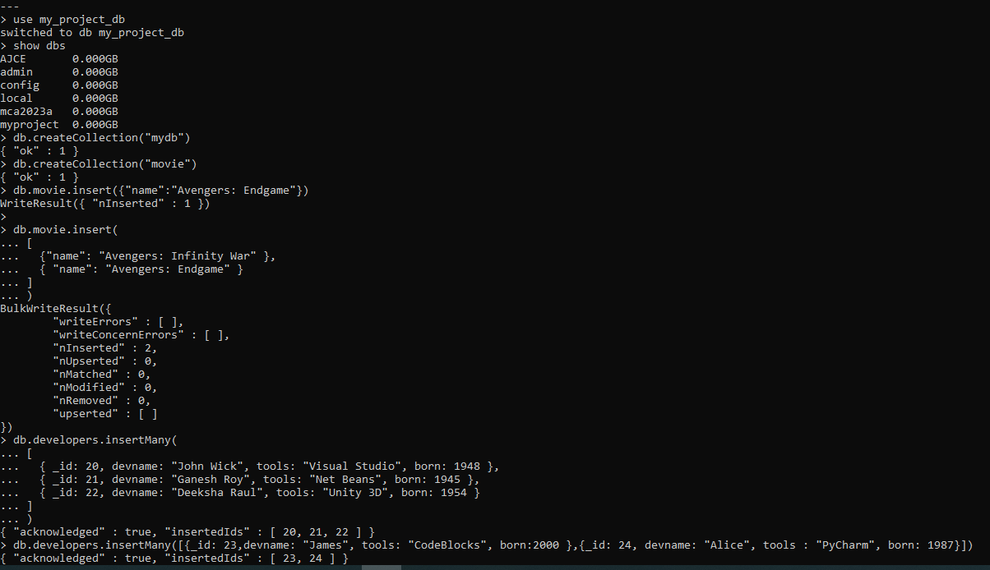

* Listing All Databases



* Creating Collections(Tables)

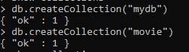

* Show Collections



* Inserting Values to Collection





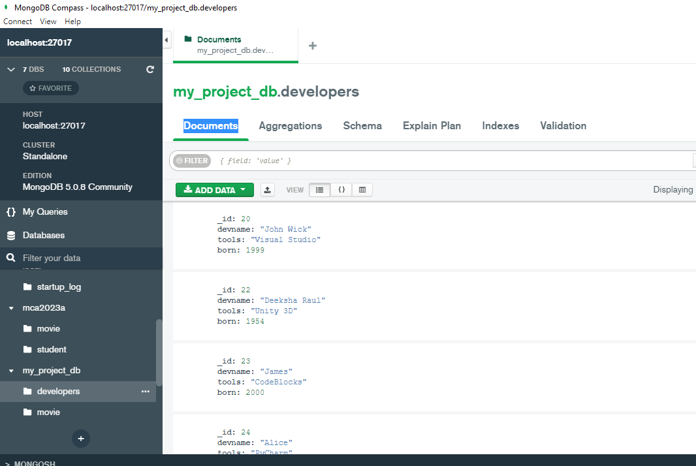

* Insert Multiple values to Collection

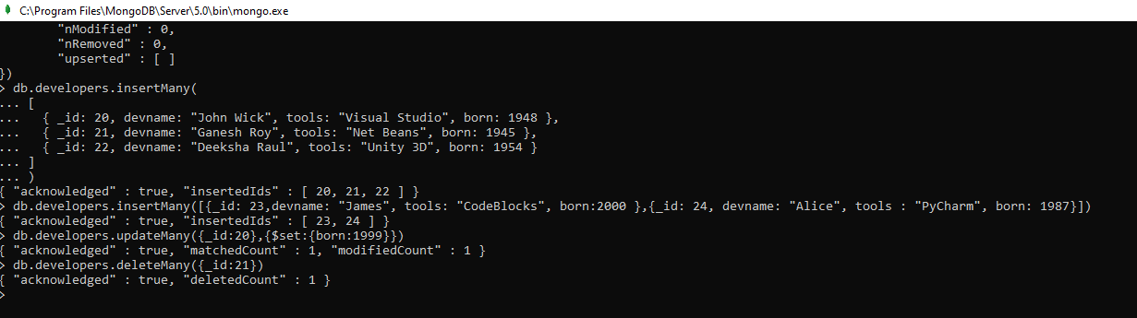

**2. READ**

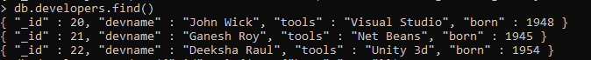

**3. UPDATE**



**4.DELETE**



